Customer Churn Project Report
Purpose
This project analyses customer churn, predicts customers who may leave, segments customers by risk and revenue, and provides safe retention recommendations.

1. Data Fixes
- TotalCharges contained spaces and was initially read as text.
- Blank values were converted to missing values.
- Missing TotalCharges values were filled with 0 because those customers had zero tenure.
- Churn was converted to binary values:
  - Yes = 1
  - No = 0
- customerID was removed because it is only an identifier.
- Categorical columns were encoded.
- Numeric columns were scaled.
- Missing values were handled before model training.

2. Train/Test Model Comparison
Model | Train Accuracy | Test Accuracy | Test Recall
Logistic Regression | 75.28% | 73.81% | 78.34%
Random Forest | 99.80% | 78.57% | 47.86%

Churn is the minority class because only about 26.54% of customers leave, while about 73.46% stay.
Accuracy can therefore look better than the model really is. For example, a simple model that predicted “No churn” for every customer would already be correct about 73.46% of the time, even though it would fail to identify a single customer at risk.
The Random Forest has a large difference between training and test accuracy. This indicates overfitting. The accuracy is only slightly higher than the simple majority prediction. This shows why accuracy alone does not tell the full story.
The recall of 78.34% means the model correctly identifies about 78 out of every 100 customers who actually churn. However, it misses about 21.66% of real churners. For the CFO, those missed customers are important because they may leave without receiving a retention action, causing avoidable revenue loss.
That is why recall is more useful than accuracy for this business problem.

Logistic Regression performs more consistently on unseen data and identifies more customers who may churn. It is currently more useful for retention planning.
Accuracy alone can be misleading because most customers do not churn. Recall is more important to the CFO because missing a customer who is likely to leave may result in lost revenue.

3. Customer Segment Recommendation

The Urgent high-value segment should receive funding first.
This segment has:
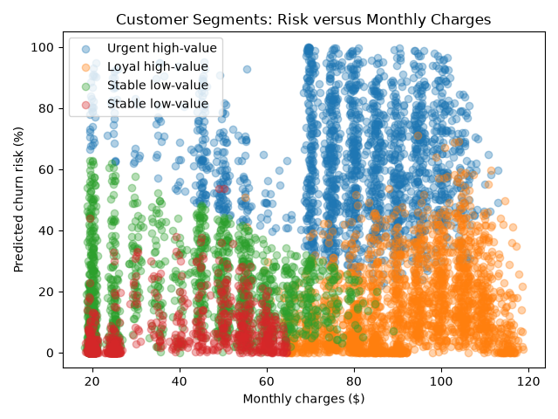
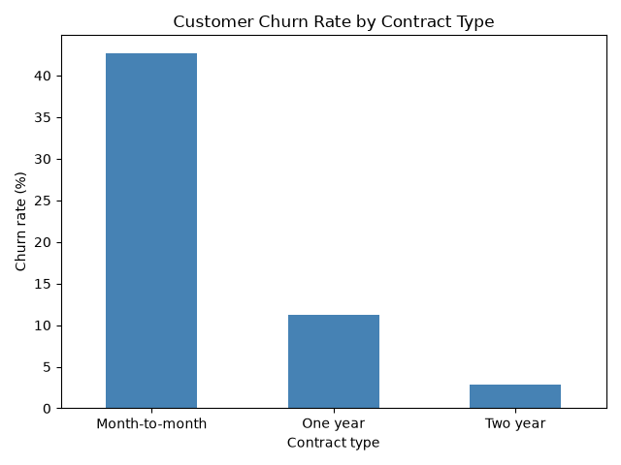
- High predicted churn risk
- High monthly charges
- Approximately $93,081.80 in expected monthly revenue at risk
The recommended actions are onboarding support, service issue resolution, and carefully approved retention offers.
The trade-off is that discounts and extra support reduce short-term profit. However, targeted spending is better than offering discounts to every customer because it focuses resources on customers with the greatest revenue exposure.

4. Hallucination Test
The approved retrieval process selected:
When the retrieval step was skipped, the simulated LLM guessed:
The guess was incorrect.
This shows why retrieval is important. Without approved context, an LLM may invent or select the wrong business rule. In a compliance and retention environment, this could result in:
- Unauthorized discounts
- False promises to customers
- Incorrect retention actions
- Inconsistent customer treatment
- Failed audits
- Financial or legal risk
The correct process is to select the approved clause using code first. The LLM should only explain the retrieved clause.
Analytical Question A
For the same customer, the model predicted a 100% churn risk and the customer had been with the company for only one month, so Clause 3 was the correct rule because new customers with less than three months of tenure must be sent to the onboarding team. When the retrieval step is skipped and the LLM is asked to choose a clause without seeing the playbook, it may guess the wrong clause. This is called hallucination or ungrounded generation. Although an actual LLM call was not available in this project, the test demonstrates the risk clearly: a wrong answer in a casual chatbot may be inconvenient, but a wrong retention clause could create an unauthorized discount, an incorrect customer action, a compliance violation, inconsistent treatment, or financial and legal risk. Therefore, the clause should always be selected by approved code first, while the LLM should only explain the retrieved clause.
Analytical Question B
Even if the churn model used fields such as gender, SeniorCitizen, Partner, or Dependents during training, passing the customer’s complete data row to the LLM could cause the generated retention explanation to mention or rely on demographic information. For example, the LLM might wrongly suggest that a customer is high risk because they are a senior citizen or have a particular family status, leading to discriminatory offers, inconsistent treatment, privacy concerns, and compliance problems. In my implementation, I prevented this by creating a restricted LLM context containing only the retrieved clause, the churn risk score, tenure, and approved non-demographic top features such as TotalCharges, MonthlyCharges, and tenure. I explicitly excluded gender, SeniorCitizen, Partner, and Dependents, added Clause 4 as a mandatory non-discrimination rule, and checked that no prohibited demographic fields were present before generating the explanation.
5. Prompt Data Filtering
The following demographic fields were removed before creating the LLM prompt:
gender
SeniorCitizen
Partner
Dependents

The LLM payload contained no demographic fields.
This prevents the LLM from directly using demographic information when creating retention explanations or recommending offers.
However, removing these columns does not guarantee complete fairness. Other fields, such as payment method, location, or service type, could indirectly represent demographic information. Fairness should therefore be checked regularly across customer groups.
6. Governance and Audit
Each retention recommendation should record:
- Pseudonymous customer ID
- Timestamp
- Model version
- Data version
- Risk score
- Selected clause ID
- Exact clause text and citation
- Features used in the explanation
- Confirmation that demographic fields were excluded
- Offer shown to the customer
- Agent decision
- Final customer outcome
These logs provide evidence that the retention process followed the approved rules and non-discrimination requirements.

